3rd Grade Vocabulary - 3rd Quarter
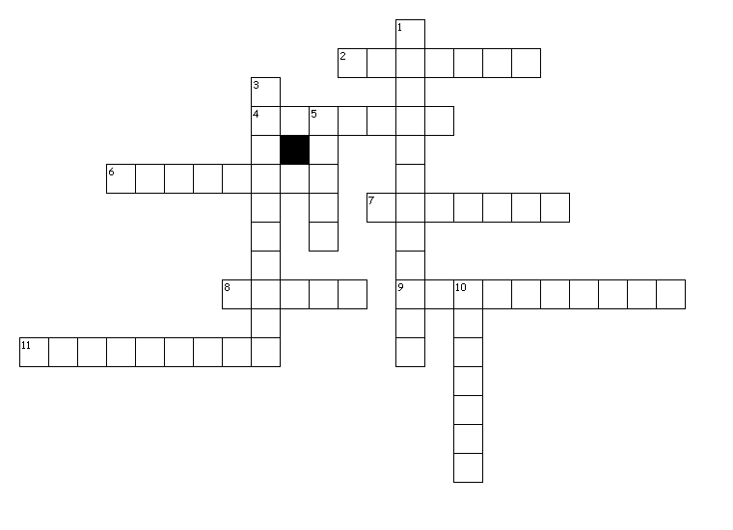
Across
2. a word that has the same or nearly the same meaning as another word of the same language. "Big" and "large" are examples.
4. a word that has the opposite meaning of another word. "Late" is the opposite of "early."
6. a story that has been handed down for generations among the common people of a region.
7. a word that is pronounced and often spelled the same as another word, but has a different meaning. In the sentence, "She was mean to me, but she didn't mean it," the two instances of "mean" are examples.
8. a short tale that teaches a lesson.
9. a book that lists the words of a language, with information about their meaning, spelling, and pronunciation.
11. to form a picture of in the mind.
Down
1. a book or set of books that has information on a wide variety of subjects.
3. a restatement of a passage or text in somewhat different words so as to simplify or clarify.
5. the main subject or topic.
10. the setting of a word or phrase that affects its meaning. The meaning of the word "fly" changes depending on what you are talking about.
Word Bank= paraphrase context synonym homonym dictionary encyclopedia
theme visualize antonym folktale fable
paraphrase a restatement of a passage or text in somewhat different words so as to simplify or clarify.
context the setting of a word or phrase that affects its meaning. The meaning of the word "fly" changes depending on what you are talking about.
synonym a word that has the same or nearly the same meaning as another word of the same language. "Big" and "large" are examples.
homonym a word that is pronounced and often spelled the same as another word, but has a different meaning. In the sentence, "She was mean to me, but she didn't mean it," the two instances of "mean" are examples.
dictionary a book that lists the words of a language, with information about their meaning, spelling, and pronunciation.
encyclopedia a book or set of books that has information on a wide variety of subjects.
theme the main subject or topic.
visualize to form a picture of in the mind.
antonym a word that has the opposite meaning of another word. "Late" is the opposite of "early."
folktale a story that has been handed down for generations among the common people of a region.
fable a short tale that teaches a lesson.

